**What’s been happening in the UK’s housing market in the first half of 2023?**

*Teaser:*

Activity in the UK housing market has weakened during the first half of 2023. This slowdown has been driven by a number of factors including the cost of living crisis, weaker real incomes and, most importantly, the tightening of monetary policy via higher interest rates.

House price growth has stalled as a consequence. The average house price was £286,532 in April, according to the latest [Halifax House Price Index for May 2023](https://www.halifax.co.uk/assets/pdf/may-2023-house-price-index.pdf). This is 1% lower than the average house price a year earlier.

This is the first annual fall in house prices since 2012. But it is worth noting that the annual decline can also be attributed to high base effects, as house prices were rising strongly in the same period last year (as detailed in an earlier [Economics Observatory article](https://www.economicsobservatory.com/update-what-next-for-the-uk-housing-market)).

At the same time, house prices have been supported – or prevented from dropping further – as a result of [planning restrictions](https://www.telegraph.co.uk/business/2019/10/20/housing-policy-madness-must-end-solutions-hand/) and [lower numbers of residential building projects in the construction sector](https://www.pmi.spglobal.com/Public/Home/PressRelease/c2fda01f14134b2ca626f49bb48256cc). Both of these factors have had the knock-on effect of keeping the supply of new homes tight and prices elevated.

**What has happened to interest rates?**

In May 2023, the Bank of England increased its policy interest rate by a further 0.25 percentage points to 4.5%, the highest it has been since the global financial crisis of 2007-09 (see Figure 2). This comes in response to continued double-digit annual general price inflation in March and elevated core inflation (see Figure 1). The difference between headline CPI inflation and core inflation is that core inflation excludes volatile food and energy prices in its calculation.

The interest rate rise was warranted to ensure that the Bank continued to fight the persistence in inflation and prevent a de-anchoring inflation expectations. Anchoring inflation expectations is key for price stability. It is vital for Central Banks to make sure the markets expectations of future inflation in the medium- to long- term to be at 2%, as this will prevent temporary shocks which increases inflation from affecting price and wage setting for a prolonged period of time. For example, if a firm expects inflation to be significantly higher than 2%, they would start to increase prices now, which will lead to greater inflationary pressures. But at the same time, with the UK economy stagnating, this action may dampen consumer spending and risk causing macroeconomic instability.

Figure 1: Annual consumer price index (CPI) and core CPI inflation in the UK, 2013-23

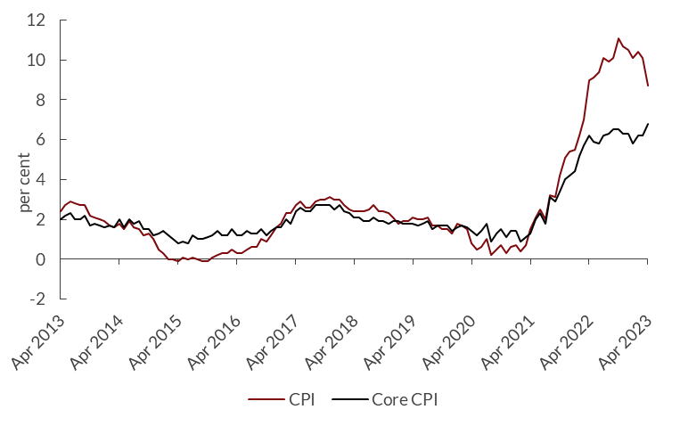

Source: Office for National Statistics (ONS)

Figure 2: Bank of England base rate, 2004-23

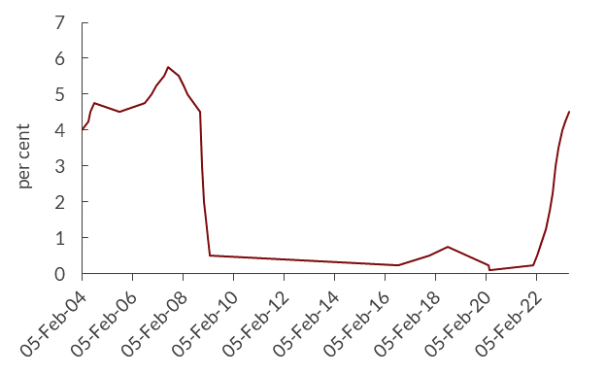

Source: Bank of England

The Bank of England expects inflation to fall back to its target of 2% at the start of 2025, moving closer to [the view that the National Institute of Economic and Social Research (NIESR)](https://www.niesr.ac.uk/wp-content/uploads/2023/05/Spring-2023-UK-Economic-Outlook.pdf) has had for a while now.

Given that inflation has proved to be more persistent than the Bank expected, this raises the possibility that bank rate will go higher and consequently that [rate cuts could be delayed until mid-2024 or beyond](https://blogs.lse.ac.uk/politicsandpolicy/will-the-bank-of-englands-strategy-pay-off/).

In April, annual CPI inflation in the UK fell to 8.7%, as significant energy price increases that we saw a year ago dropped out of the figures. But core inflation accelerated further to 6.8% – the highest rate since March 1992.

**What does this mean for mortgages and house prices?**

Interest rates on loans provided by financial institutions, including residential mortgages, follow the Bank rate and rates in financial markets. As a result, an increase in bank rate will be translated into higher mortgage rates, although not necessarily by the same magnitude.

The resulting rise in debt servicing costs will directly and immediately affect variable and tracker rate mortgage holders rather than fixed rate mortgage owners. But buyers applying for a new fixed rate mortgage or existing fixed rate mortgage owners who are looking to refinance will also be affected by higher interest rates on their mortgages if rates in financial markets move up as the bank rate increases.

Figure 3: Overall weighted average interest rate on mortgages (%), 2007-23

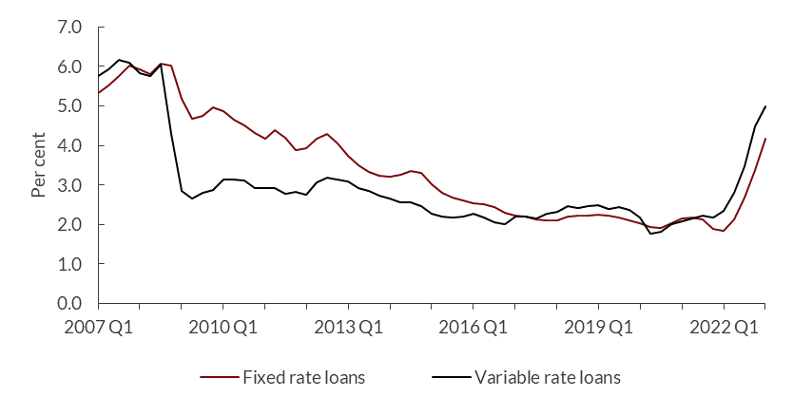

Source: Financial Conduct Authority (FCA)

The weighted average interest rate on fixed rate residential loans and variable-rate loans increased by around 0.8 and 0.5 percentage points respectively compared with the previous quarter, according to the latest official data available for the first quarter of 2023.

Mortgage rates are on average 2.3 and 2.8 percentage points higher than in the last quarter of 2021 (Figure 3). More recent data from [Moneyfacts](https://moneyfactscompare.co.uk/mortgages/), a price comparison site, indicate that the average five-year mortgage rate increased from 4.97% at the beginning of May to 5.41% as of 9 June 2023. .

Similarly, the average two-year fixed mortgage rate rose from 5.26% to 5.83% as of 9 June 2023. If these rates are compared to the average mortgage rates provided by the Financial Conduct Authority (FCA) in Figure 3, the average mortgage rates in the UK are now close to the levels seen during the global financial crisis.

[Nationwide](https://www.nationwide.co.uk/mortgages/bank-of-england-base-rate-changes-and-your-mortgage/), the UK’s second largest mortgage lender, has reported that the standard mortgage rate on its variable rate mortgage product will increase from 7.74% to 7.99% from 1 July 2023, in line with the Bank of England bank rate rise.

Higher monthly mortgage repayments will reduce personal disposable income and negatively affect discretionary consumption and GDP. Prior to the latest policy changes, [NIESR](https://www.niesr.ac.uk/wp-content/uploads/2023/05/Spring-2023-UK-Economic-Outlook.pdf) forecast that real personal disposable incomes would continue falling in 2023 and 2024, by 0.7% and 1.1%, respectively.

Continued declines in private consumption and the risk of higher unemployment are likely to mean that the drop in housing demand is likely to continue, due to affordability issues. This, in turn, means that house prices are likely to fall further.

First-time buyers will particularly be discouraged from applying for a mortgage because of rising debt servicing costs. As of the first quarter of 2023, the average mortgage payment for first-time buyers has risen to almost 40% of net pay, which is the highest proportion since 2008 (see Figure 4).

Further, the Bank of England estimates that approximately [1.3 million households](https://www.ft.com/content/26de68c7-35af-45bf-97bb-7c6ba8d9ce84) will need to refix their mortgage rates between April and December 2023.

Current five-year rates are at levels not seen since the global financial crisis. This is putting stress on lenders for their fixed rate offers, which has led to lenders pulling mortgages off the market and repricing.

More importantly, if these market rate levels continue, there will be many fixed rate borrowers looking to refinance over the next year but facing much higher rates to do so. Subsequently, refinancing is now the big risk in the housing market.

Figure 4: Monthly mortgage payments for first-time buyers (percentage of net pay)

Source: Nationwide

The [government has stated](https://www.gov.uk/government/publications/stamp-duty-land-tax-temporary-reductions-for-residential-properties/stamp-duty-land-tax-temporary-increase-to-thresholds#:~:text=This%20measure%20was%20initially%20announced,change%20which%20is%20wholly%20relieving.) that the stamp duty cut and increase to nil-rate tax thresholds – which were announced on 23 September 2022 – will remain in place until 31 March 2025. But this is unlikely to encourage a large number of new house purchases considering the prevailing elevated prices and continued squeeze in incomes as a result of the cost of living crisis.

**How is the cost of living crisis affecting the housing market?**

Despite recent good news on falling energy price inflation, annual food price inflation in April was estimated at 19% – close to the 45-year high recorded in March 2023 (19.1%).

The rapid rate of food price inflation will no doubt continue to erode household budgets and squeeze discretionary spending opportunities, including spending on residential property purchases for first-time buyers or even existing homeowners wishing to move.

The number of housing transactions, which is a measure of housing demand, has been falling since the second half of 2022, and with it the growth in house prices (see Figures 5 and 6). The annual decline in housing transactions over the first four months of 2023 was almost 20%, compared with the annual average decline of 7% in 2022.

While the number of mortgage approvals – an indicator of future borrowing for the purchase of houses – rose in March, the average decline over the first four months of 2023 was 35% compared with 20% in 2022.

Figure 5: Monthly housing transactions and mortgage approvals, 2019-2023

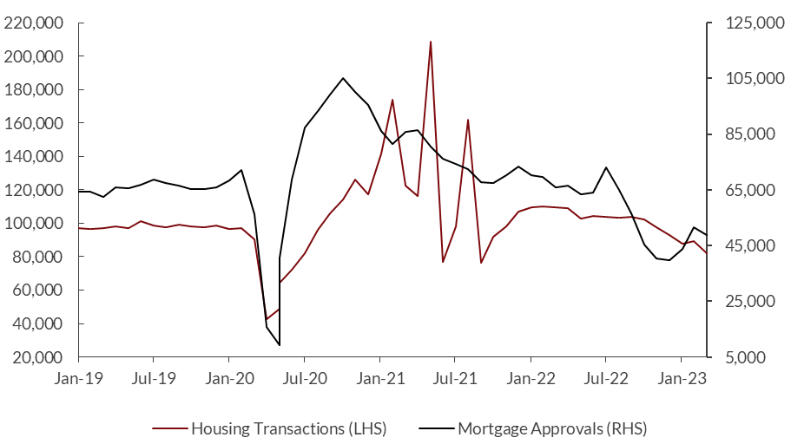

Source: Bank of England

Likewise, the value of [new mortgage commitments](https://www.bankofengland.co.uk/statistics/mortgage-lenders-and-administrators/2023/2023-q1) in the first quarter of 2023 was estimated at £48.9 billion, almost 41% lower than a year earlier. This is also the lowest value since the second quarter of 2020.

This decline further reinforces the reduction in housing market activity because of the double whammy of higher mortgage rates and weaker real incomes.

Figure 6: Annual percentage change in house prices

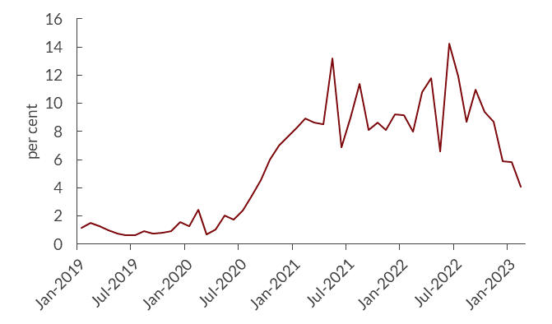

Source: UK Government

The pattern of reduced growth in house prices has been seen across England, Northern Ireland, Scotland and Wales. While the profile of house price dynamics differs across regions, all have been affected by weaknesses in real income and tighter monetary policy (see Figure 7).

The average annual growth in house prices for the first three months of 2023 ranges from 6% in England and Wales, to 2% in Scotland – much lower than 9-12% in the first quarter of 2022.

The regional disparities in house price inflation arise from multiple factors, including, but not limited to, [buyers being more cautious in some areas](C://Users/u.patel/Downloads/May%202023%20UK%20Residential%20Market%20Survey.pdf), the supply of housing being tighter in some areas than others, and buyers expecting house prices to fall further and therefore looking to delay their purchases.

Figure 7: Average UK house prices, by region

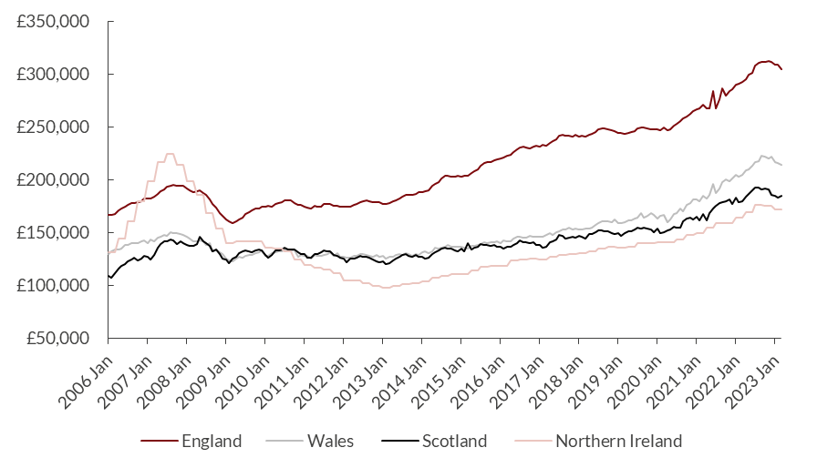

**Source: ONS, HM Land Registry**

**Should we expect a large fall in house prices?**

First, the risk that the Bank of England may need to raise the bank rate further – due to persistent underlying domestic inflationary pressures – increases the risks of a significant decline in house prices. This would also lead to negative spillover effects across both the housing market and the wider economy.

At present, the market is [expecting the interest rate to peak at 5.75%](https://www.bankofengland.co.uk/statistics/yield-curves) by year end, compared with 4.75% in the [Bank of England’s Monetary Policy Report on 11 May](https://www.bankofengland.co.uk/monetary-policy-report/2023/may-2023" \l ":~:text=The%20Bank%20of%20England's%20Monetary,percentage%20points%2C%20to%204.5%25.). The Bank argues that around two-thirds of the impact of the previous increases in interest rates is yet to materialise, therefore further rate hikes (in addition to the impact yet to unfold) would worsen the situation.

An alternative view is that the worrying economic outlook has reduced the risk appetite of lenders. This, in turn, has helped to prevent the build-up of systemic risk and therefore large-scale disruption in the housing market, particularly as house servicing costs rise.

In the first quarter of 2023, the outstanding value of all residential mortgage loans in the UK fell to £1,675 billion. This drop was the first quarterly reduction since the second quarter of 2017. In addition, the value of gross mortgage advances was £58.8 billion in the first quarter of 2023, which was £22.9 billion lower than the previous quarter, and the lowest level since the second quarter of 2020.

Second, income levels are likely to be maintained. This is due to the continued tight labour market, which is helping to push up nominal earnings in response to higher price inflation; the fall in energy bills due to lower wholesale prices; and the extension of the energy price guarantee (EPG) until June followed by OFGEM, the UK’s independent energy regulator, reducing the energy price cap from July. This may stimulate housing market activity and support house prices.

Third, in June 2014, [the Bank of England’s Financial Policy Committee](https://www.economicsobservatory.com/what-next-for-the-uk-housing-market) introduced more thorough affordability checks on potential mortgages, alongside banks facing limits on the supply of very high loan-to-income mortgages. This set of ‘macroprudential’ policies has helped to manage mortgage lending risks.

Figure 8: Proportion of residential lending to individuals, by type, 2009-23

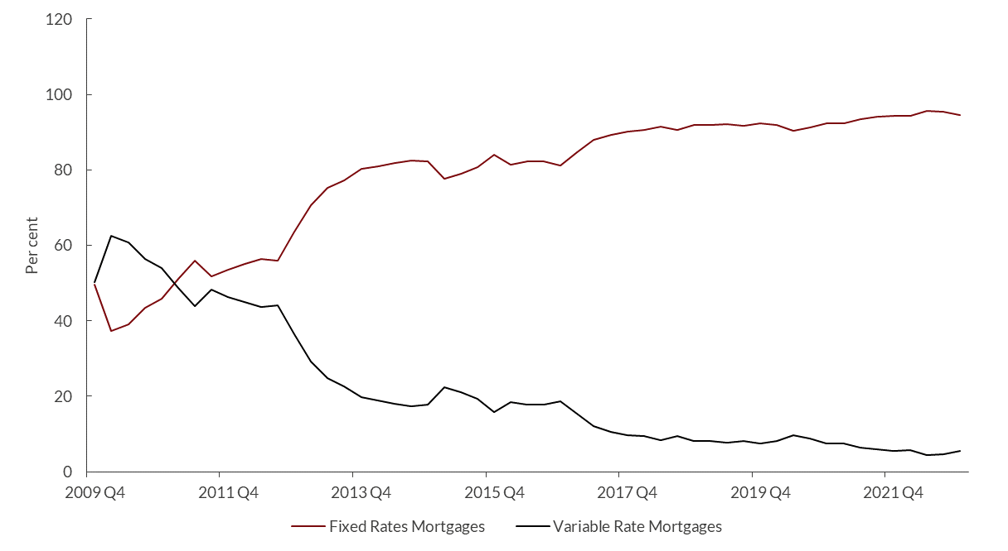

Source: FCA

Fixed rate mortgages are now the lion’s share of total mortgages in the UK, reducing the immediate exposure of borrowers to rising bank rate (Figure 8). These homeowners are already tied into a mortgage product that offers, for example, a fixed rate of interest for either two years or five years.

As of March 2022, around 60% of current fixed rate mortgages were on five-year contracts. This means that an increase in bank rate is not going to have an immediate effect on households’ monthly repayments and cause repercussions to the entire UK housing market, unless these households are refinancing or applying for a new fixed rate mortgage.

In 2021-22, [35% of households](https://www.gov.uk/government/statistics/english-housing-survey-2021-to-2022-headline-report/english-housing-survey-2021-to-2022-headline-report) were outright owners, and so would be unaffected by interest rate rises as they do not have mortgages on their properties.

Figure 9: Residential loans to individuals, 2007-23

Source: FCA

The greater proportion of double income households with mortgages in the UK are likely to help prevent large scale defaults, as suggested in an earlier [Economics Observatory article](https://www.economicsobservatory.com/update-what-next-for-the-uk-housing-market) (Figure 9).

At the beginning of 2023, 66% of residential loans were held by joint income applicants. A household managed by two individuals with two sources of income is likely to be better equipped to cushion itself against higher living costs. The prevalence of these types of homeowners will therefore also reduce the probability of large-scale defaults even if mortgage rates continue to rise.

It is also possible that two employed and financially secure individuals may be more confident when purchasing a house, irrespective of the current climate, further providing underlying support to housing demand and thus prices.

[NIESR](https://www.niesr.ac.uk/wp-content/uploads/2023/05/Spring-2023-UK-Economic-Outlook.pdf) forecasts a fall in UK house prices between their peak in the fourth quarter of 2022 and the fourth quarter of 2025 of around 9.6%. This is only half of the fall experienced in the global financial crisis, between October 2007 and February 2009, where house prices plummeted 21%.

Even after a decline of almost 10%, the level of house prices would remain high compared with historical standards and similar to where they were at the end of 2021. It is key to note that the growth in house prices will be depressed but the level of house prices will continue to be strong compared with historical standards.

Considering the gloomy outlook of the UK economy, this may weigh on the UK housing market over the medium to long term. As Figure 7 shows, despite the dip in regional house prices this year, they are still around 20-30% higher than in December 2019, before Covid-19 hit.

**What about the rental market?**

Higher interest rates, which feed into higher mortgage rates, may mean that more would-be first-time buyers stay into the rental market rather than purchasing a home, given debt servicing costs in a period of squeezed budgets. This, in turn, would support rental demand and prices.

[In April, private rental prices in the UK were 4.8% higher than in April 2022.](https://www.ons.gov.uk/economy/inflationandpriceindices/bulletins/indexofprivatehousingrentalprices/april2023) At a regional level, annual private rental prices rose by 4.7% in England, 4.8% in Wales, and 5.2% in Scotland. In England, the highest private rental inflation was in London, and Yorkshire and the Humber at 5.0%.

Fig 10: Annual growth in rental prices in the UK, 2016-23

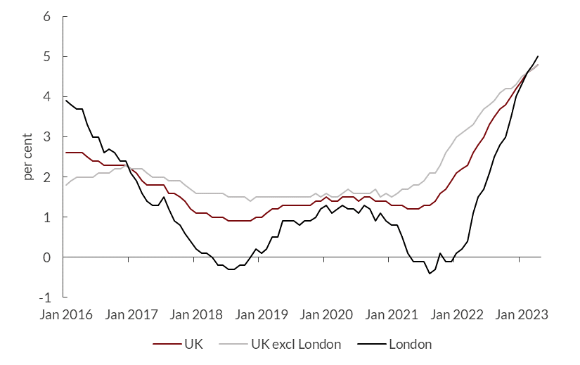

Source: ONS

Rental price inflation continues to accelerate in the UK because of falling landlord instructions and strong demand, which has created a mismatch between supply and demand. Tighter regulations (and higher mortgage costs) are encouraging landlords to sell properties, which is resulting in a drop in supply of properties for rent.

[The Royal Institute of Chartered Surveyors (RICS) report for April 2023](C://Users/u.patel/Downloads/May%202023%20UK%20Residential%20Market%20Survey.pdf) notes that two-thirds of survey participants reported an increase in the number of buy-to-let landlords looking to sell their properties. Similarly, two-thirds reported a decline in interest from new UK-based buy-to-let investors over the past six months. Tight supply and higher demand are likely to keep rental rate growth high – at just below 6% a year over the course of the next five years.

At the beginning of May 2023, [Skipton Building Society](https://www.ft.com/content/2ae32dbc-d7af-4614-88e9-e5bc1fa5e036), the UK’s fourth largest building society, launched its 100% mortgage on a five-year fixed rate of interest of 5.49%. This mortgage carries no product fee and has a mortgage limit of £600,000.

These 100% mortgage products were launched leading up to the global financial crisis and then removed. Skipton has aimed this product at renters wishing to purchase their first home and does not require a deposit.

This highly-leveraged product could be seen as having a substantial risk considering the uncertainty in house prices. But in reality, it is likely to represent a very small share of total mortgages and first-time buyers may wish to build up a deposit to lock in at a lower interest rate, meaning it is unlikely to cause significant disruptions in the housing market.

**Conclusion**

The unexpected persistence of underlying inflation in the UK is proving to be a problem for the Bank of England and the latest market expectations indicate further increases in the policy interest rate.

The rapid tightening of monetary policy, and the prospect of further tightening, poses clear risks to the housing market. If interest rates rise too high, there is a risk that house prices will decline sharply.

But lenders’ lower risk appetite, the larger share of fixed rate mortgages than 15 years ago, and a relatively higher proportion of outright owners offer some protection against a severely adverse outlook.

Further, if market rates – which are already at their highest since the global financial crisis – continue to rise further, then the large number of fixed rate borrowers looking to refinance over the next year will feel significant stress.

Currently between April and December, there are 1.3 million households needing to refix their mortgages. It is these households that now represent the big risk in the housing market, and could lead to significant financial disruption.

Where can I find out more?

1. [UK house prices record first annual fall since December 2012](https://www.ft.com/content/5d2b9983-2f4c-4a1b-a781-5ca3ceed06f1). Discussion of the latest house price index for May 2023.
2. UK Residential Market Survey. RICS survey and analyse the current and future conditions in UK residential sales and lettings.

3. [Nationwide House Price Index](https://www.nationwidehousepriceindex.co.uk/reports). Provides insights into the latest trends in the UK housing market and also provides a range of data on the housing market.Who are experts on this questions?

* Barry Naisbitt (NIESR)
* Paul Cheshire (LSE)
* David Miles (Imperial College London)
* Geoff Meen (University of Reading)
* Christine Whitehead (LSE)

Author: Urvish Patel

Topics:

Families and households

Prices and interest rates

Banks and financial markets

Recession and recovery

Sidebar links:

How does the housing market affect UK productivity?

How does the housing market affect wealth inequality?

Retrofitting the UK housing stock: what lessons from Scotland’s tenements?

Update: What next for the UK housing market?

Does rent control work?